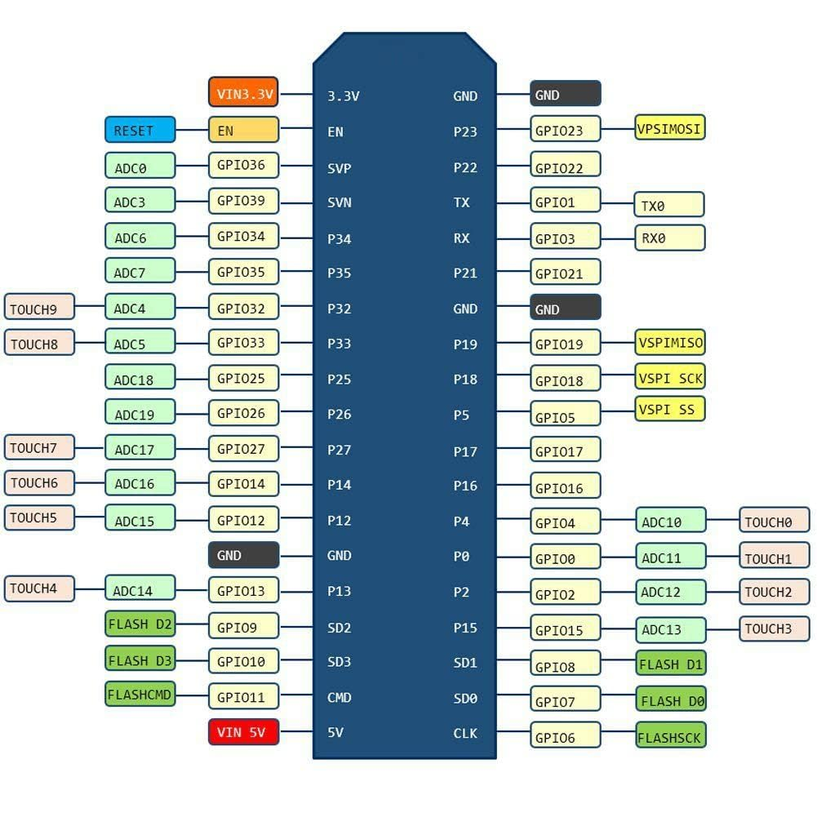Documentation for Drink master 8000

Motor0: Soda

Motor1: Juice

Motor2: Syrup

Motor3: Prosecco

Motor4: Aperol

Motor5: White Rum

Motor6: Gin

Motor7: Vodka

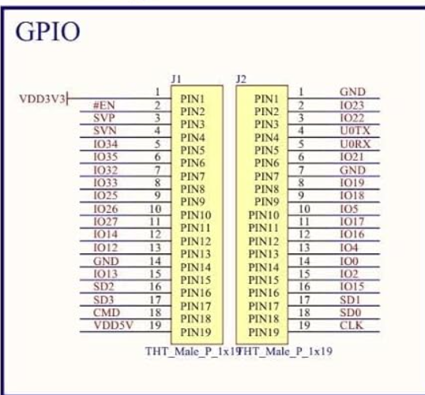Vstupy vystupy:

a

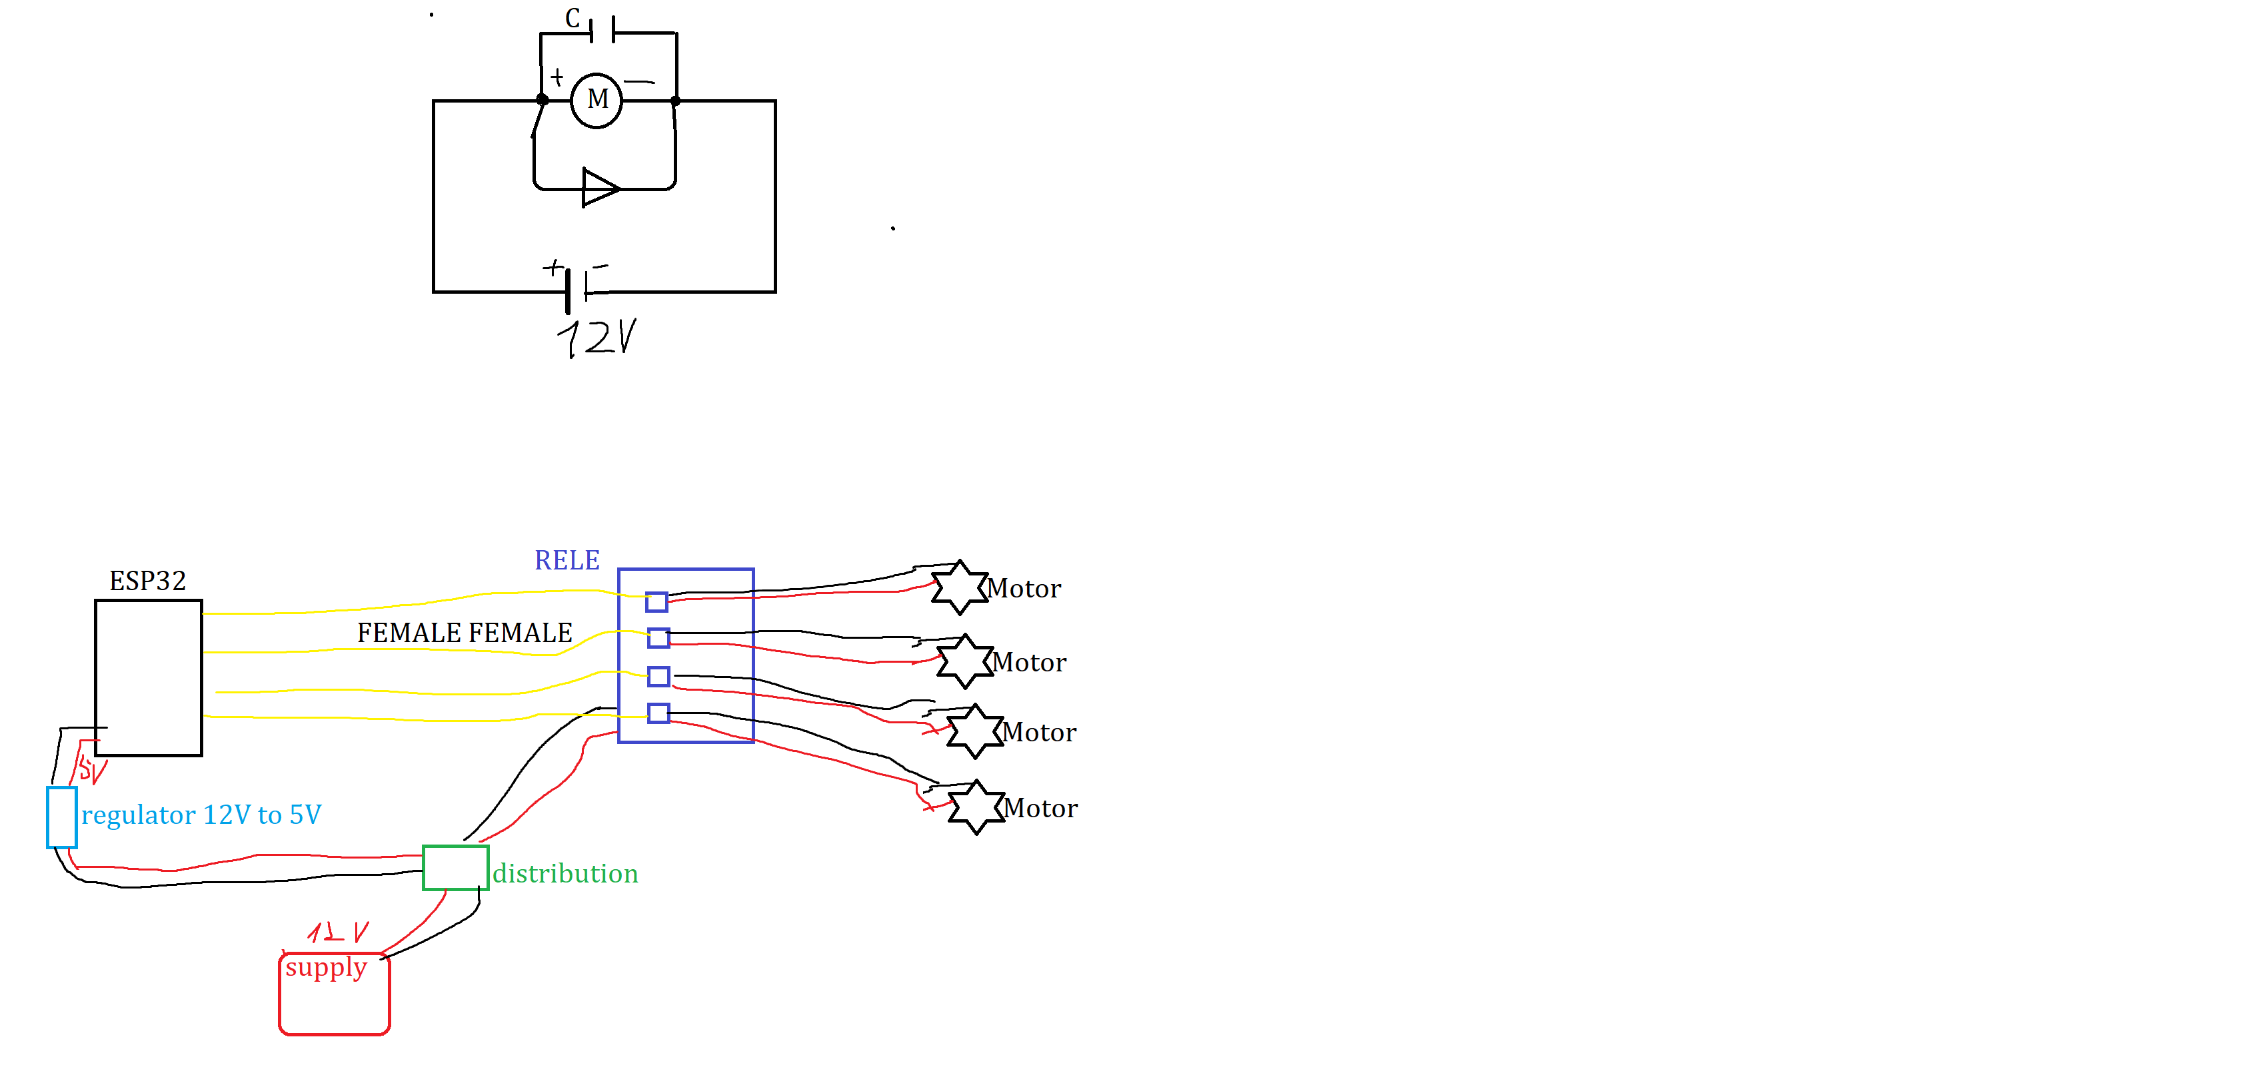

Drinks:

1. Aperol Spritz
2. Vodka Soda
3. Margarita
4. Tequila Sunrise
5. Mojito
6. Rum Punch
7. Rum Soda
8. Vodka Juice
9. Tequila Soda
10. Rum & Soda
11. Vodka Prosecco
12. Vodka Lemon
13. Vodka Spritz
14. #include <WiFi.h>
15. #include <BLEDevice.h>
16. #include <RemoteXY.h>
17. // you can enable debug logging to Serial at 115200
18. //#define REMOTEXY__DEBUGLOG
19. // RemoteXY select connection mode and include library
20. #define REMOTEXY_MODE__ESP32CORE_BLE
21. #include <BLEDevice.h>
22. // RemoteXY connection settings
23. #define REMOTEXY_BLUETOOTH_NAME "BN_DrinkMaster8000"
24. #include <RemoteXY.h>
25. // RemoteXY GUI configuration
26. #pragma pack(push, 1)
27. uint8_t RemoteXY_CONF[] =   // 803 bytes
28. { 255,30,0,0,0,28,3,18,0,0,0,8,1,106,200,5,1,0,0,0,
29. 0,4,0,129,3,17,98,12,64,179,68,114,105,110,107,32,77,97,115,116,
30. 101,114,32,56,48,48,48,0,131,5,81,97,22,9,179,165,24,77,105,120,
31. 101,100,32,68,114,105,110,107,115,0,166,2,131,33,130,40,14,9,121,123,
32. 24,68,114,105,110,107,115,0,170,1,1,8,157,90,25,3,138,27,67,108,
33. 101,97,110,80,114,111,103,114,97,109,0,14,0,1,0,0,53,43,3,1,
34. 31,65,112,101,114,111,108,32,83,112,114,105,116,122,0,130,247,43,119,1,
35. 27,17,1,53,0,53,43,3,119,31,77,111,106,105,116,111,0,1,0,44,
36. 53,43,3,163,31,68,97,105,113,117,105,114,105,0,130,247,87,119,1,27,
37. 17,1,53,44,53,43,3,65,31,71,105,110,32,83,117,110,114,105,115,101,
38. 0,1,0,88,53,44,3,79,31,83,99,114,101,119,100,114,105,118,101,114,
39. 0,130,247,132,119,1,27,17,1,53,88,53,44,3,124,26,84,111,109,67,
40. 111,108,108,105,110,115,0,1,0,133,53,43,3,67,31,66,101,101,115,75,
41. 110,101,101,0,1,53,133,53,43,3,39,31,71,105,110,80,111,109,0,130,
42. 249,175,119,1,27,17,130,53,219,1,213,27,17,131,31,180,49,16,2,17,
43. 2,31,78,101,120,116,32,80,97,103,101,0,154,2,14,0,131,27,177,54,
44. 22,2,17,2,31,78,101,120,116,32,80,97,103,101,0,106,2,1,0,0,
45. 53,43,3,152,27,71,105,109,108,101,116,0,130,247,43,119,1,27,17,1,
46. 53,0,53,43,3,141,31,82,105,99,107,101,121,0,1,0,44,53,43,3,
47. 96,26,71,105,110,70,105,122,122,0,130,247,87,119,1,27,17,1,53,44,
48. 53,43,3,124,26,83,111,117,116,104,115,105,100,101,0,1,0,88,53,44,
49. 3,1,31,70,111,114,75,105,100,115,0,130,247,132,119,1,27,17,1,53,
50. 88,53,44,3,31,25,71,105,110,83,111,100,97,0,1,0,133,53,43,3,
51. 51,31,82,117,109,32,80,117,110,99,104,0,1,53,133,53,43,3,193,31,
52. 71,105,110,78,74,117,105,99,101,0,130,249,175,119,1,27,17,130,53,219,
53. 1,213,27,17,10,0,131,29,176,48,22,2,17,2,31,76,97,115,116,32,
54. 80,97,103,101,0,170,1,1,0,0,53,43,3,95,27,86,111,100,107,97,
55. 32,76,101,109,111,110,0,130,247,43,119,1,27,17,1,53,0,53,43,3,
56. 162,31,86,111,100,107,97,32,83,111,100,97,0,1,0,44,53,43,3,64,
57. 26,86,111,100,107,97,32,83,112,114,105,116,122,0,130,247,87,119,1,27,
58. 17,1,53,44,53,43,3,161,31,82,117,109,83,111,100,97,0,1,0,88,
59. 53,44,3,1,31,71,105,110,32,83,112,114,105,116,122,0,130,231,132,78,
60. 1,27,17,130,53,222,1,167,27,17,13,0,1,255,0,55,45,3,0,31,
61. 83,111,100,97,0,130,249,45,119,1,27,17,1,54,0,53,45,3,52,31,
62. 74,117,105,99,101,0,1,0,46,54,43,3,68,27,83,121,114,117,112,0,
63. 130,249,89,119,1,27,17,1,54,46,53,43,3,177,31,80,114,111,115,101,
64. 99,99,111,0,1,0,90,54,44,3,1,31,65,112,101,114,111,108,0,130,
65. 249,134,119,1,27,17,1,54,90,53,44,3,31,25,87,104,105,116,101,82,
66. 117,109,0,1,0,135,54,42,3,166,27,71,105,110,0,1,55,135,52,42,
67. 3,193,31,86,111,100,107,97,0,130,251,177,119,1,27,17,130,54,221,1,
68. 213,27,17 };
70. // this structure defines all the variables and events of your control interface
71. struct {
72. // input variables
73. uint8_t clean_program; // =1 if button pressed, else =0
74. uint8_t AperolSpritz; // =1 if button pressed, else =0
75. uint8_t Mojito; // =1 if button pressed, else =0
76. uint8_t Daiquiri; // =1 if button pressed, else =0
77. uint8_t GinSunrise; // =1 if button pressed, else =0
78. uint8_t Screwdriver; // =1 if button pressed, else =0
79. uint8_t TomCollins; // =1 if button pressed, else =0
80. uint8_t BeesKnee; // =1 if button pressed, else =0
81. uint8_t GinPom; // =1 if button pressed, else =0
82. uint8_t VodkaLemon; // =1 if button pressed, else =0
83. uint8_t VodkaSoda; // =1 if button pressed, else =0
84. uint8_t VodkaSpritz; // =1 if button pressed, else =0
85. uint8_t Southside; // =1 if button pressed, else =0
86. uint8_t GinSpritz; // =1 if button pressed, else =0
87. uint8_t GinSoda; // =1 if button pressed, else =0
88. uint8_t RumPunch; // =1 if button pressed, else =0
89. uint8_t GinNJuice; // =1 if button pressed, else =0
90. uint8_t VodkaLemon; // =1 if button pressed, else =0
91. uint8_t VodkaSoda; // =1 if button pressed, else =0
92. uint8_t VodkaSpritz; // =1 if button pressed, else =0
93. uint8_t Southside; // =1 if button pressed, else =0
94. uint8_t GinSpritz; // =1 if button pressed, else =0
95. uint8_t Soda; // =1 if button pressed, else =0
96. uint8_t Juice; // =1 if button pressed, else =0
97. uint8_t Syrup; // =1 if button pressed, else =0
98. uint8_t Prosecco; // =1 if button pressed, else =0
99. uint8_t Aperol; // =1 if button pressed, else =0
100. uint8_t WhiteRum; // =1 if button pressed, else =0
101. uint8_t Gin; // =1 if button pressed, else =0
102. uint8_t Vodka; // =1 if button pressed, else =0
103. // other variable
104. uint8_t connect_flag;  // =1 if wire connected, else =0
105. } RemoteXY;
106. #pragma pack(pop)  // netusim co to je je to z toho programu aj vsetko nad comentom je odtial
107. const char* ssid = "Drink_Master_8000";
108. const char* password = "DM8000";
109. //#define PIN_GINSUNRISE 2  // from remotexy takto oni zadefinovaly pin 2 idk co je lepsie
110. //>> motor names to pin-outs
111. int SodaM = 12;
112. int JuiceM = 14;
113. int SyrupM = 27;
114. int ProseccoM = 26;
115. int AperolM = 25;
116. int WhiteRumM = 33;
117. int GinM = 32;
118. int VodkaM = 35;
119. //<< motor names to pin-outs
121. void setup() {
122. //speed na ktorej bezi procesor>>
123. Serial.begin(115200);
124. // tu hovorim ze hej tento pin je output
125. pinMode(SodaM, OUTPUT);
126. pinMode(JuiceM, OUTPUT);
127. pinMode(SyrupM, OUTPUT);
128. pinMode(ProseccoM, OUTPUT);
129. pinMode(AperolM, OUTPUT);
130. pinMode(WhiteRumM, OUTPUT);
131. pinMode(GinM, OUTPUT);
132. pinMode(VodkaM, OUTPUT);
133. BLEDevice::init("RemoteXY");
134. RemoteXY_Init(); // Initialize RemoteXY
135. }
136. const float ml_50 = 1000;  //in milseconds use for delay
137. void nalievaj(int motor_pin, int ML) {
138. delay(3000);
139. digitalWrite(motor_pin, HIGH);
140. delay(ML);
141. digitalWrite(motor_pin, LOW);
142. delay(3000);
143. }
144. void makeTomCollins(){
145. nalievaj(GinM, ml_60);
146. nalievaj(JuiceM,ml_30);
147. nalievaj(SyrupM,ml_15);
148. }
149. void makeBeesKnee(){
150. nalievaj(GinM, ml_60);
151. nalievaj(JuiceM,ml_25);
152. nalievaj(SyrupM,ml_15);
153. }
154. void makeGinNJuice(){
155. nalievaj(GinM, ml_50);
156. nalievaj(JuiceM,ml_100);
157. nalievaj(SyrupM,ml_25);
158. }
159. void makeGinPom(){
160. nalievaj(GinM, ml_50);
161. nalievaj(JuiceM,ml_50);
162. nalievaj(SodaM,ml_50);
163. }
165. void makeGimlet(){
166. nalievaj(GinM, ml_60);
167. nalievaj(JuiceM,ml_25);
168. nalievaj(SyrupM,ml_25);
169. }
170. void makeRickey(){
171. nalievaj(GinM, ml_60);
172. nalievaj(SodaM,ml_30);
173. nalievaj(SyrupM,ml_10);
174. }
175. void makeGinSpritz() {
176. nalievaj(GinM, ml_75);
177. nalievaj(ProseccoM, ml_50);
178. }
179. void makeGinFizz() {
180. nalievaj(GinM, ml_75);
181. nalievaj(SyrupM, ml_30);
182. nalievaj(JuiceM, ml_20);
183. nalievaj(SodaM, ml_30);
184. }
185. void makeSouthside(){
186. nalievaj(GinM, ml_50);
187. nalievaj(JuiceM, ml_20);
188. nalievaj(SyrupM, ml_15);
189. }
190. void makeVodkasoda() {
191. nalievaj(VodkaM, ml_60);
192. nalievaj(SodaM, ml_120);
193. nalievaj(JuiceM, ml_25);
194. }
195. void makeGinSunrise() {
196. nalievaj(GinM, ml_60);
197. nalievaj(SyrupM, ml_15);
198. nalievaj(JuiceM, ml_120);
199. }
200. void makeMojito() {
201. nalievaj(WhiteRumM, ml_60);
202. nalievaj(SodaM, ml_90);
203. nalievaj(SyrupM, ml_15);
204. nalievaj(JuiceM, ml_30);
205. }
206. void makeRumPunch() {
207. nalievaj(WhiteRumM, ml_60);
208. nalievaj(SyrupM, ml_15);
209. nalievaj(JuiceM, ml_90);
210. }
211. void makeScrewdriver() {
212. nalievaj(VodkaM, ml_50);
213. nalievaj(JuiceM, ml_100);
214. }
215. void makeAperolSpritz() {
216. nalievaj(AperolM, ml_60);
217. nalievaj(ProseccoM, ml_90);
218. nalievaj(SodaM,ml_30);
219. }
220. void makeGinSoda() {
221. nalievaj(GinM, ml_60);
222. nalievaj(SodaM, ml_120);
223. }
224. void makeRumSoda() {
225. nalievaj(WhiteRumM, ml_60);
226. nalievaj(SodaM, ml_120);
227. }
228. void makeVodkaSpritz() {
229. nalievaj(VodkaM, ml_30);
230. nalievaj(ProseccoM, ml_90);
231. nalievaj(JuiceM, ml_15);
232. }
233. void makeDaiquiri() {
234. nalievaj(WhiteRumM, ml_50);
235. nalievaj(JuiceM, ml_25);
236. nalievaj(SyrupM, ml_10);
237. }
238. void makeVodkaLemon() {
239. nalievaj(VodkaM, ml_60);
240. nalievaj(JuiceM, ml_90);
241. nalievaj(SyrupM, ml_30);
242. nalievaj(SodaM, ml_90);
243. }
244. void makeForKids(){
245. nalievaj(SodaM, ml_250);
246. nalievaj(SyrupM, ml_25);
247. }
248. void makeSoda() {
249. nalievaj(SodaM, ml_300);
250. }
251. void makeJuice() {
252. nalievaj(JuiceM, ml_300);
253. }
254. void makeSyrup() {
255. nalievaj(SyrupM, ml_30);
256. }
257. void makeProsecco() {
258. nalievaj(ProseccoM, ml_100);
259. }
260. void makeAperol() {
261. nalievaj(AperolM, ml_50);
262. }
263. void makeRum() {
264. nalievaj(WhiteRumM, ml_50);
265. }
266. void makeGin() {
267. nalievaj(GinM, ml_50);
268. }
269. void makeVodka() {
270. nalievaj(VodkaM, ml_50);
271. }
272. void cleanAll() {
273. nalievaj(SodaM, ml_100);
274. nalievaj(JuiceM, ml_100);
275. nalievaj(SyrupM, ml_100);
276. nalievaj(ProseccoM, ml_100);
277. nalievaj(AperolM, ml_100);
278. nalievaj(WhiteRumM, ml_100);
279. nalievaj(GinM, ml_100);
280. nalievaj(VodkaM, ml_100);
281. }
282. void loop() {
283. // Poll RemoteXY
284. RemoteXY_Handler();
285. // Check for each button and call the corresponding function
286. if (RemoteXY.clean_program) {
287. cleanAll();  // Clean all components
288. }
289. if (RemoteXY.AperolSpritz) {
290. makeAperolSpritz();
291. }
292. if (RemoteXY.Mojito) {
293. makeMojito();
294. }
295. if (RemoteXY.Daiquiri) {
296. makeDaiquiri();
297. }
298. if (RemoteXY.VodkaLemon) {
299. makeVodkaLemon();
300. }
301. if (RemoteXY.VodkaSoda) {
302. makeVodkasoda();
303. }
304. if (RemoteXY.VodkaSpritz) {
305. makeVodkaSpritz();
306. }
307. if (RemoteXY.RumSoda) {
308. makeRumSoda();
309. }
310. if (RemoteXY.Juice) {
311. makeJuice();
312. }
313. if (RemoteXY.Soda) {
314. makeSoda();
315. }
316. if (RemoteXY.Syrup) {
317. makeSyrup();
318. }
319. if (RemoteXY.Prosecco) {
320. makeProsecco();
321. }
322. if (RemoteXY.Aperol) {
323. makeAperol();
324. }
325. if (RemoteXY.WhiteRum) {
326. makeRum();  // Assuming White Rum and Rum have the same functionality
327. }
328. if (RemoteXY.Gin) {
329. makeGin();
330. }
331. if (RemoteXY.Vodka) {
332. makeVodka();
333. }
334. //tu nemam v apke
335. if (RemoteXY.GinSunrise) {
336. makeGinSunrise();
337. }
338. if (RemoteXY.GinSoda) {
339. makeGinSoda();
340. }
341. if (RemoteXY.RumPunch) {
342. makeRumPunch();
343. }
344. if (RemoteXY.Screwdriver) {
345. makeScrewdriver();
346. }
347. if (RemoteXY.TomCollins) {
348. makeTomCollins();
349. }
350. if (RemoteXY.BeesKnee) {
351. makemakeBeesKnee();
352. }
353. if (RemoteXY.GinNJuice) {
354. makeGinNJuice();
355. }
356. if (RemoteXY.GinPom) {
357. makeGinPom();
358. }
360. if (RemoteXY.Gimlet) {
361. makeGimlet();
362. }
363. if (RemoteXY.Rickey) {
364. makeRickey();
365. }
366. if (RemoteXY.GinSpritz) {
367. makeGinSpritz();
368. }
369. if (RemoteXY.GinFizz) {
370. makeGinFizz();
371. }
372. if (RemoteXY.Southside) {
373. makeSouthside();
374. }
375. if (RemoteXY.ForKids) {
376. makeForKids();
377. }
378. }